**Screenshots and Github link**

**https://github.com/Has-has/Web_Design_Assign_2.git**

Product Picture

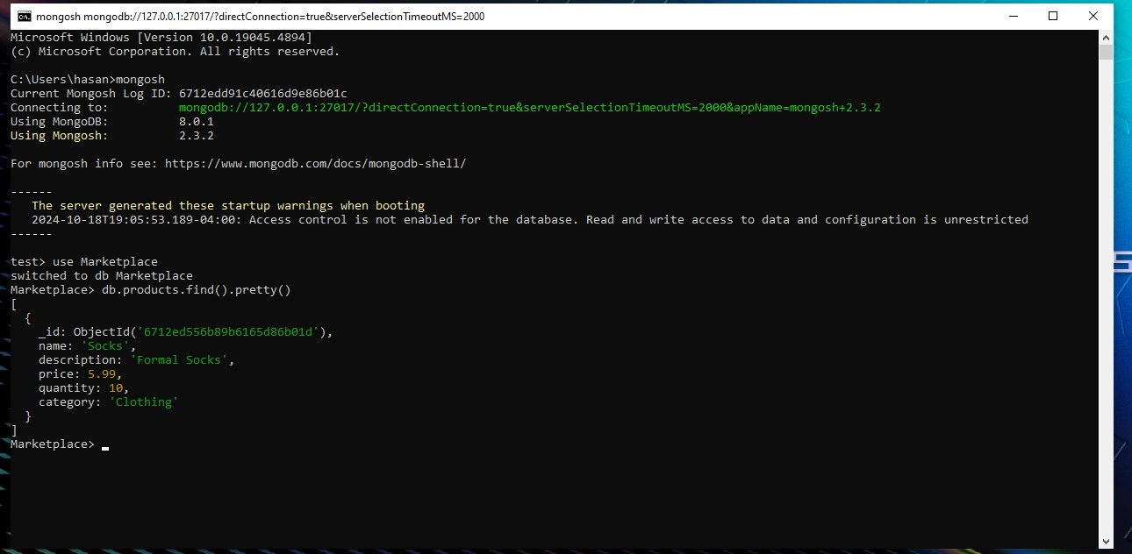

The Welcome Picture

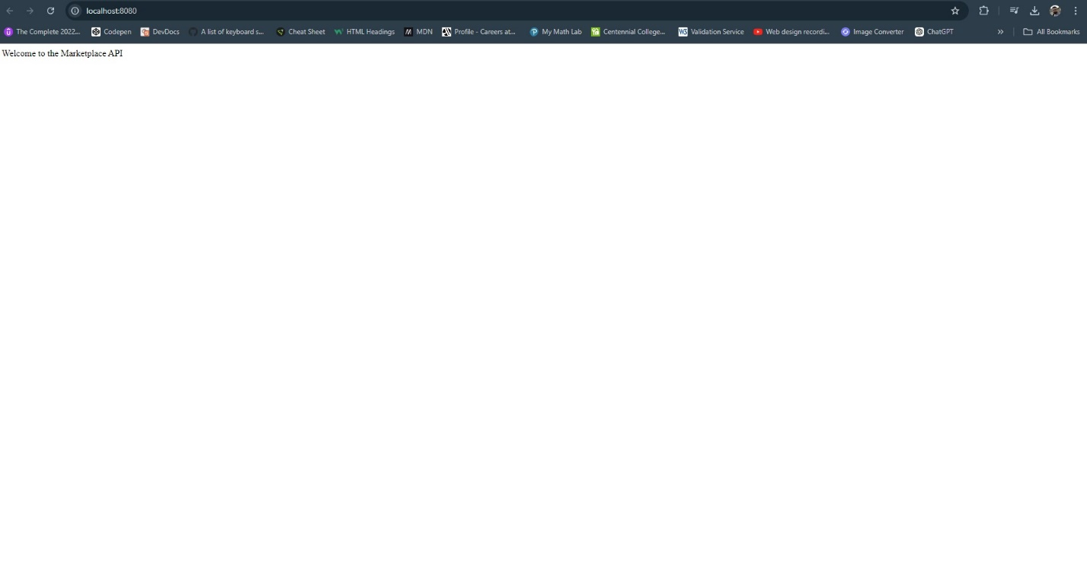

Put_Product_Test

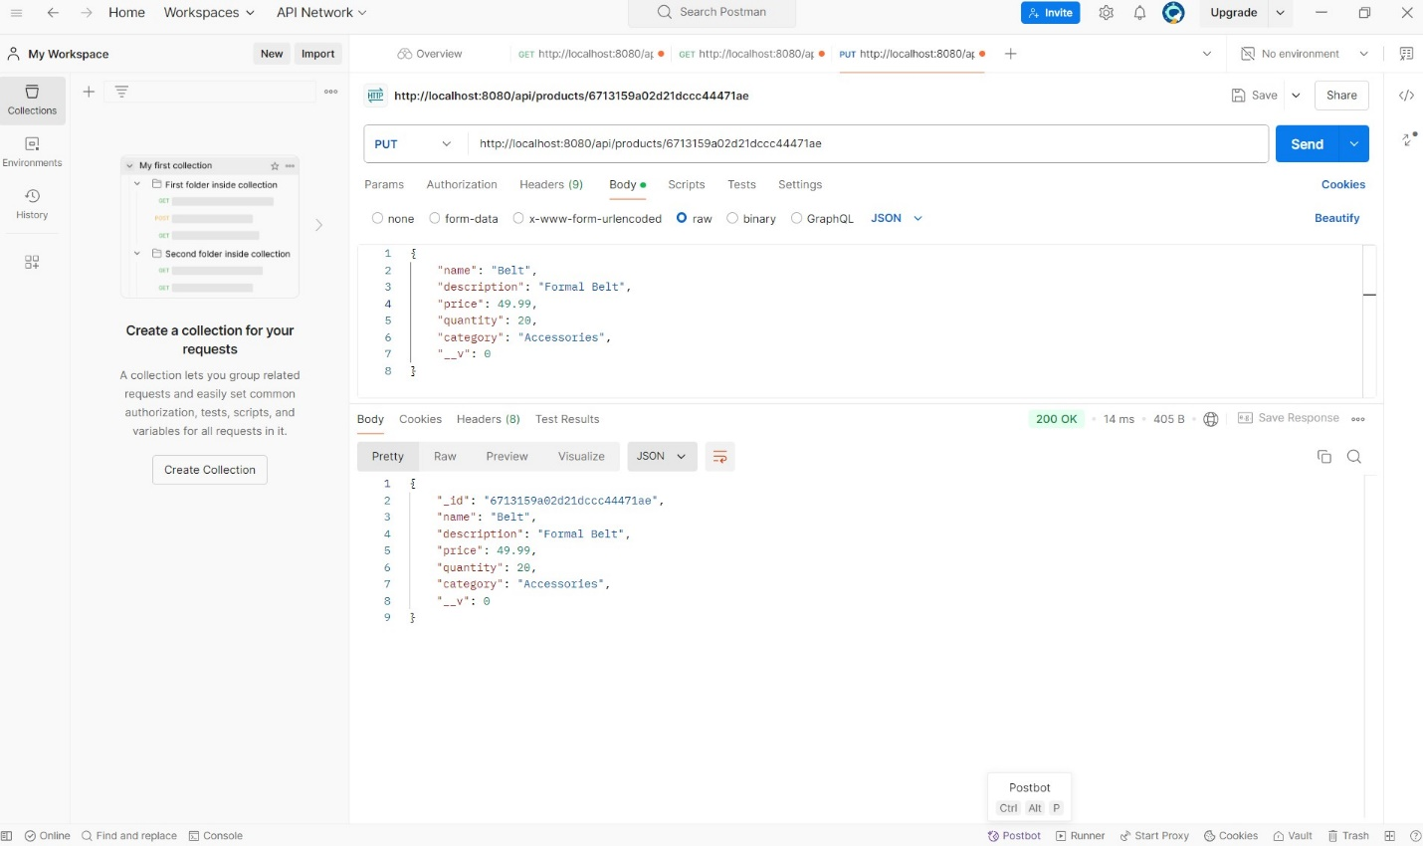

Post_Products_Test

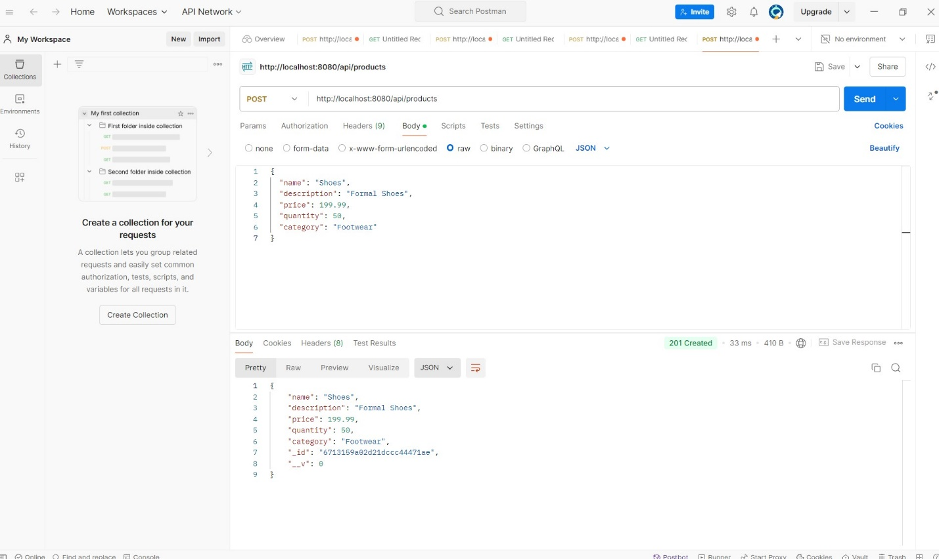

Get_Products_Test

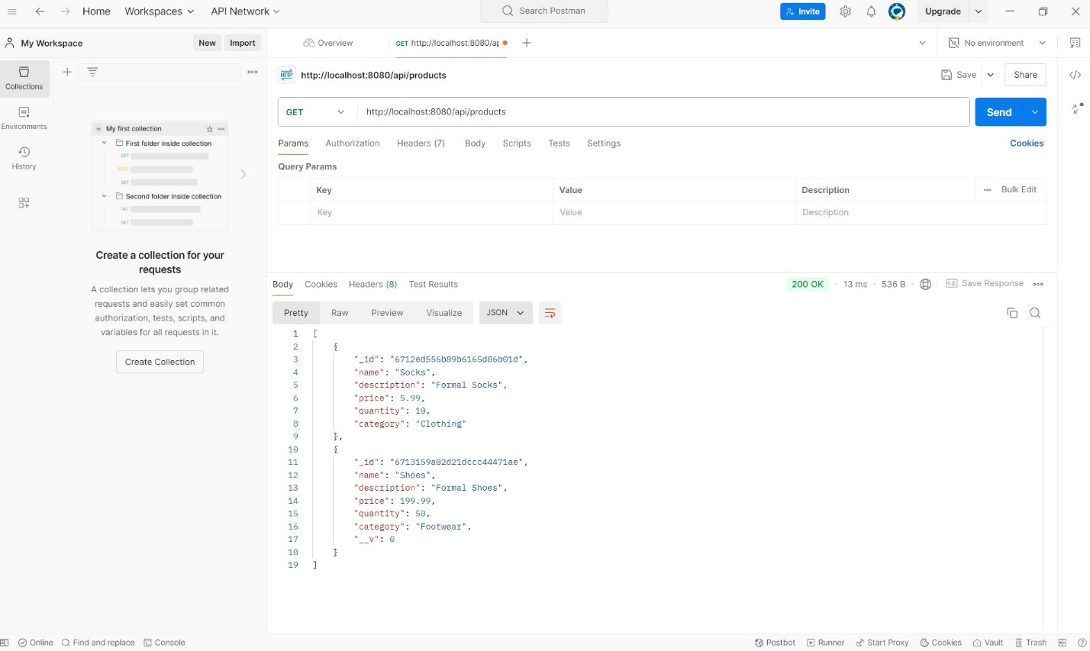

Get_ID_Test

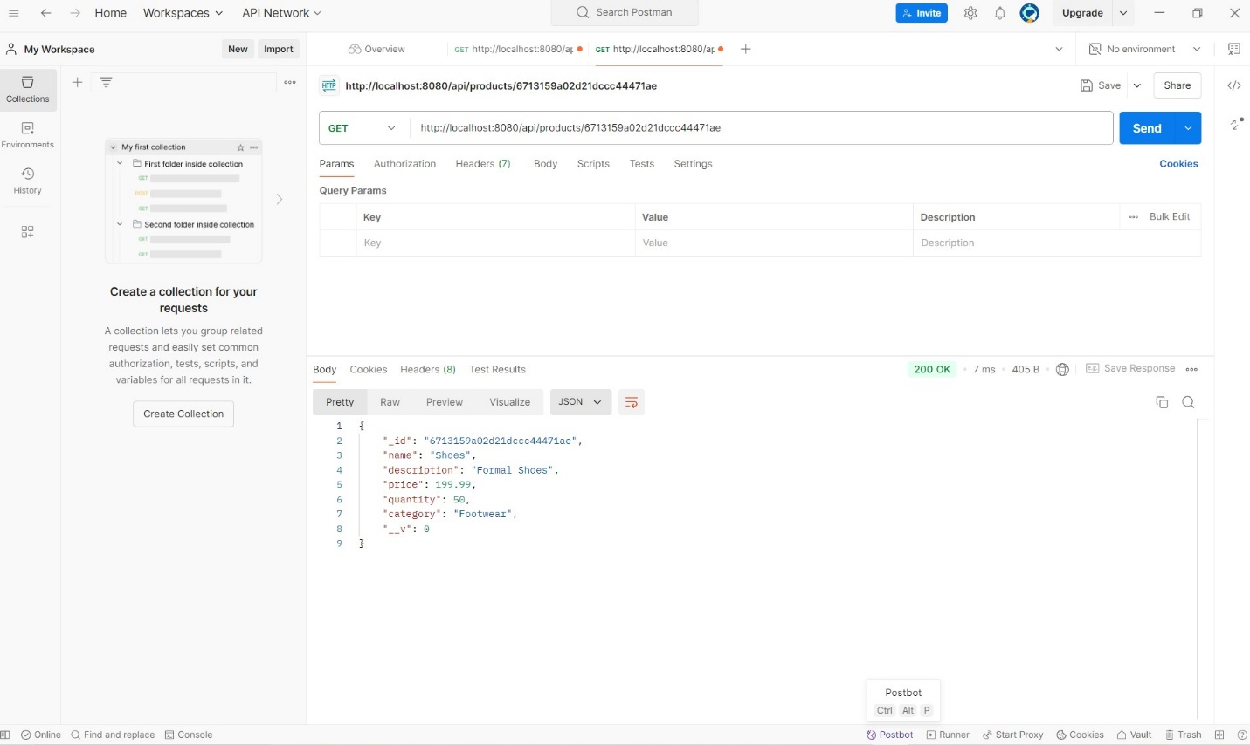

Delete_Product_Test

